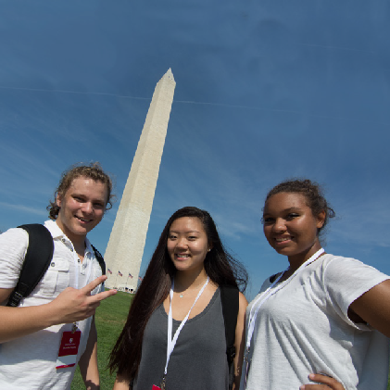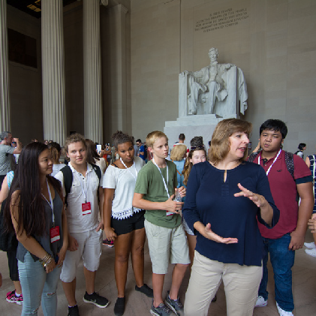

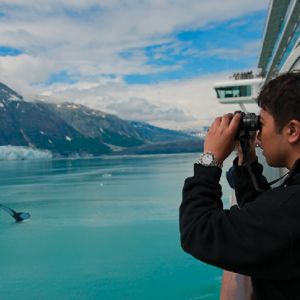

You’re invited to… available!

join your classmates on the trip to **Washington, D.C.**

**Trip Dates: 6/7/2022 – 6/10/2022  
Registration Deadline: June 4, 2021**

**Early bird price is $1,792 which is a $100 savings if you register by June 4th**

**Our Trip ID is: 192297**

**Signing up for the trip is easy!**

* ONLINE: worldstrides.com/signup
* PHONE: Call WorldStrides Customer Service at 800-468-5899

*Due to the COVID19 pandemic, we suggest utilizing online registration as our call volume is higher than usual.

Questions? contact Martina Mileski at mmileski@gladstone.k12.mi.us

**Would you like more information?**

Text: **WASHINGTONDC** To: **855-452-8747**

This is to view trip video, program highlights & information on financial assistance programs.

*Text message are intended for subscribers over the age of 13. Message and data rates may apply. You may opt out of any future messages at any time by texting STOP to 855-452-8747.*